|  |
| --- |
| Startup Critical Analysis and Reasons for Failure for The IAARHIES INTERNATIONAL CONFERENCE ON BUSINESS AND ECONOMICS – 2017 |
|  |
| Ikboljon Kasimov,  External Affairs Specialist, TA, RA,  Erasmus+ Project Manager,  International Relations Department,  Andijan Machine Building Institute, Andijan, Uzbekistan |
| **1/5/2017** |

ABSTRACT

This research project aims to analyze variety of problems encountered by Startups and emphasizes some of the major reasons for failure. Wrong market positioning, terrible hiring, poor resource management, unbalanced partnerships and overpromising are some of the failure reasons discussed. It also provides examples of startups with successful operations, including UBER, inDinero, Spotify, Hara Software Inc. and GoInstant in various sectors of the economy in different countries. Building up on some of the theories of Eric Ries, the author of “Lean Startup” and entrepreneur, this study discusses the importance of individual teams and lean startup methodology in new venture success. Likewise, fundamental ingredients for entrepreneurial prosperity and longevity, such as having the right people, focusing on the customer rather than the product or technology, creating value and hiring and firing fast are also highlighted herein this study. Overall, scrutinized analysis of startups reveal that successful entrepreneurial ventures can be established through careful planning, organizing, learning, accurate timing and being creative and innovative.

**Total: 2202 Words**

Table of Contents

I. Introduction to Entrepreneurship and Startups 1

II. Literature Review and Critical Analysis 2

III. Conclusion 7

IV. Examples of Prosperous Startups in Europe and UK 8

V. References 9

# Introduction to Entrepreneurship and Startups

“I knew that if I failed I wouldn’t regret that, but I knew the one thing I might regret is not trying.”

Jeff Bezos, Founder and CEO of Amazon

Entrepreneurship is an act of transforming worthwhile ideas into products that are useful and successful in the marketplace. (Robert A. Barron, 2013) Elton Musk can be a great example of a successful entrepreneur. He is an inventor, investor, and founder of Zip2, Paypal, SpaceX, CEO of Tesla, and Chairmen of SolarCity. Entrepreneurship is also the critical driver of innovation, responsiveness and productivity in today’s dynamic market with vigorous changes in supply and demand. Therefore, today entrepreneurs work on more risky and uncertain business environment than ever. However, combination of strong desire to launch an enterprise and well thought new idea along with comprehensive planning and team effort can lead to achieving tremendous financial rewards. (Dean A. Shepherd, 2011)

In many countries such as the USA and the UK entrepreneurship became the driving sector of economic stability and growth. It is because entrepreneurs create new ventures, generate jobs, increase market competition, quality and productivity and seek for continuous improvement. For instance, there are almost 28 million entrepreneurial ventures in United States and approximately 75 percent of the net new jobs created by those self-employed entrepreneurs which represent 99.7 percent of all U.S employers. (Forbes, 2013)

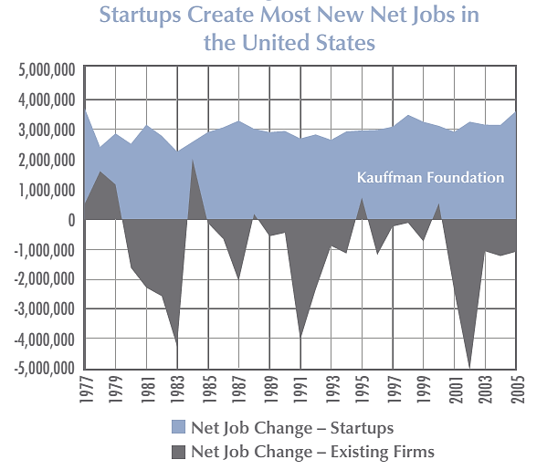

Source: *“Business Dynamics Studies,”* Tim Kane

Recent study “Importance of Startups in Economy,” shows that existing large firms loose more jobs than they create, especially during the period of recession. However, creation of jobs remains stable in startups while existing large firms suffer from net job loss due to business cycle sensitivity. Moreover, new business establishments innovate far more than the existing administrative companies and enrich people’s lives by increasing consumer choice, customizing and providing them with goods and services for needs they didn’t even know they had. (US Bureau of International Information Programs, 2012)

The Vice President of product for GoInstant software – development platform, Benjamin Yoskovitz states that “Entrepreneurs, generally, are more about doing than talking about doing” and if that is not in your nature then you are more likely to struggle as an entrepreneur. (Benjamin Yoskovitz, 2014) Indeed, it is imperative to have an idea in mind, but it takes certain personality and set of skills to critically evaluate, improve and put that idea into an action to achieve success.

# Literature Review and Critical Analysis

Harvard Business School Sarofim-Rock Professor and the lion of entrepreneurship, Howard Stevenson claims that Administrative Companies (AC’s) are different than Startups in six essential ways and those critical factors give the AC’s the advantage over new establishments in wars of attrition. According to him “Startups pursue opportunities with resources that don’t match the task; although they may have one or two critical ones such as product idea or access to an experimental customer, they lack all resources required to win” (Peter, Cohan S, 2012, p178)

His six ways of difference between startups and administrative companies include:

* Strategic Orientation
* Style of Resource Commitment
* Decision-Making Approach
* Attitude towards Asset Accumulation
* Management Structure and Style
* Approach to Rewards

In all six ways AC’s possess tremendous advantage over new establishments because he certainly has selected very critical sectors of difference. Even though, his statement might seem to be accurate when looking at the rate of unsuccessful startups or their failure stories, his assumptions are actually controversial.

Marc Andreessen, a successful entrepreneur, investor, software engineer, founder of Netscape, and who is in Board of Directors for Facebook, HP, and EBay, has listed three essential ingredients for startups. In his point of view, startups can always succeed if there is a big market opportunity, startups introduce better product and possess an outstanding team. Startups survive the market even if they make a compromise in product and ensure that the other two pillars of the firm are well-founded. (Jolts, 2013)

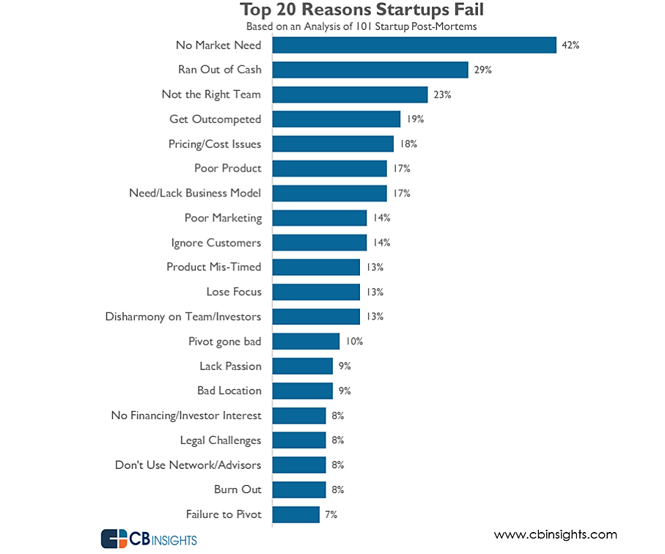A major research conducted by Bradly University and University of Tennessee Research centers shows that the financial strength of large firms is far superior to new ventures and thus AC’s are able to offer large scale operations and invest in research and development and marketing campaigns. They are also likely to benefit from economies of scale achieved through mass production that results in lower costs and potentially lower prices and credibility and strong brand image that supports large organizations. Erin Griffith conducted research on startup failure and listed the top 20 reasons of new venture failure. This statistics is based on the analysis of 101 Startups.

Source: *“Why Startups fail, according to their founders,”* Erin Griffith, 2014

In addition, George Deeb has studied over 500 startups during the past few years listed out 13 unlucky reasons of startup failures: lack of funding, wrong market positioning, no-go-to-market-strategy, not focus, no flexibility, no patience or persistence, wrong or incomplete leadership, unmotivated team, no mentors or advisors, no revenue model, less capital then required, bad luck or timing. (George Deep, 2013) Twitpic, photo hosting service, provides a good example of a company who failed to fulfill customer expectations and manage its resources. The founder, Noah Everett remarked that “We don’t have the resources to fend off a large company like Twitter to maintain our mark which we believe whole heartedly is rightfully ours. Therefore, we have decided to shut down Twitpic.” (Twitpic, 2014) Another unsuccessful startup, Dijiwan, a digital marketing firm closed down within six months due to terrible hiring and management, reckless expenses, unbalanced partnerships and contracts ratios, and ignoring problems. The founder emphasized that “a good product idea and strong technical team are not a guarantee of a successful business.” (Oncletom, 2012)

Different analyses of startup failures might mislead our opinion towards accepting the generalized assumption of Howard Stevenson on startup failure. However, mainstream entrepreneurs, investors and professors of entrepreneurial studies consider entrepreneurial startups as replacements to administrative companies. There countless startup success stories worldwide which are incredibly extraordinary. Those startups have now become the market leaders and innovators and setting the standards of price, quality and service in global markets. A private transportation firm founded by Travis Kallanick and Garrett Camp, UBER Inc. is a significant example of successful entrepreneurial establishment. Today, four years old Uber has reached 45 countries and operates in 200 cities worldwide and has recently been valued at over US $18.2 billion. (CNN Money, 2014)

William Sahlman, Harvard Business School Professor and research expert on startup success factors has completely different judgment over startups. In the opinion of Professor Sahlman, entrepreneurial firms are far superior in customizing their products based on the unique needs of customers. In addition, small businesses can identify their core customer base much faster and easier and even involve them in product development processes through close customer relationships. He mentions some of the critical elements of small entrepreneurial business longevity and success.

* Having the right people
* Focusing on customers rather than product or technology
* Concentrating on sales

Moreover, to his way of thinking, new ventures should concentrate on the process of acquiring customers rather than raising money and getting them to provide capital because the best money comes from the customers. (William Sahlman, 2007)

“Sometimes the big fish is not always the best fish” says successful entrepreneur Joseph Pigato who turned down a lucrative offer from technology market giant Apple Inc. to join a startup, Sparked; mobile-first customer engagement platform. According to the managing director of Sparked, entrepreneurs should look for a compelling problem and market demand for its solution before considering a particular startup and if there is no substantial demand then look for alternative startups. (Joseph Pigato, 2013)

The author of “The Lean Startup and” and entrepreneur Eric Ries had proposed a different approach to reasons of startup failures. He emphasizes that new ventures fail because they build product that nobody wants to buy, no matter how great the technology is, it is the biggest waste in new startup. Therefore, before establishing a new venture any entrepreneur should scrutinize the strengths of small businesses in comparison to large enterprises in particular market and must seize those competitive advantages. He criticizes the existence of departments in new ventures and suggests building two individual teams:

* Problem Team
* Solution Team

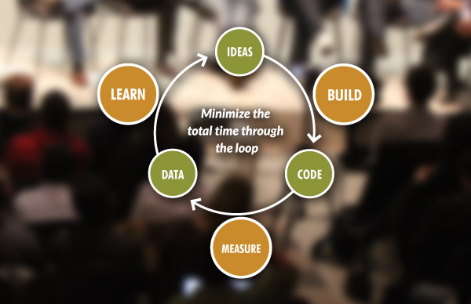Problem Team finds out who the customer is and what problem the venture is trying to solve. On the other hand, the Solution Team evaluates whether the current product hypothesis are any good or not. Nonetheless, they are two independent teams; they operate in close synchronization to discover if the current pivots are good and if they are not then they focus on alternatives. Likewise, Eric Ries introduced the Lean Startup Methodology that provides scientific approach to creating and managing new ventures and empowering them to get the desired products to customers faster. (Eric Ries, 2011)

Source: *“The Lean Startup Methodology,”* Eric Ries

As in lean manufacturing, the lean startup eliminates the waste in processes, creates order and adds extra value to the product to exceed customer expectations in possible minimum time. In lean startup, ventures generate ideas, collect relative data and develop minimum viable product (MVP) to start the learning process. Startups use special investigative method called “Five WHY’s” to solve emerging problems during learning and measuring stages of lean startup and eventually, product is built if the MVP is sustainable at all stages. Overall, the lean startup is an inexpensive approach to starting a new business achieved by maximized use of existing resources. “By the time that the product is ready to be distributed widely, it will already have established customers” states Eric Ries. (The Lean Stratup, 2013)

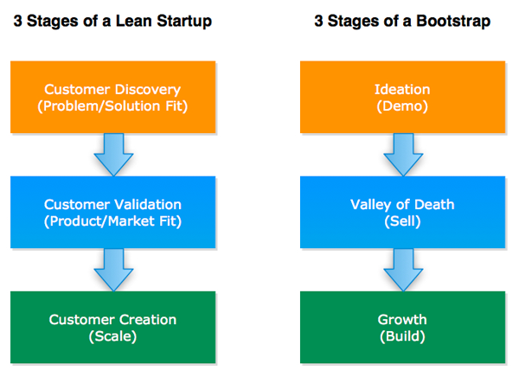In his methodology, Ries established three stages to build a successful entrepreneurial venture.

The primary objective of Customer Discovery stage is finding a problem that is worth solving and establishing hypotheses to evaluate the feasibility and viability of proposed solution.

In Customer Validation phase the startup constructs the minimum viable product that fits the requirements, wants and needs of potential customers based on the learnings from customer discovery stage.

At the last stage, the main objective of an entrepreneur becomes to scale. It will be the time to raise more capital if necessary because the investors recognize the progress and growth of the venture and will be ready to offer additional funding to. (Ash Muarya, 2010)

According to many well – known entrepreneurs such as Jessica Mah, Cofounder and CEO of “inDinero” (Accounting, Taxes and Payroll for businesses), timing of setting up a new business and traits of an entrepreneur are highly significant factors. Personal characteristics, skills and knowledge of entrepreneur are as significantly important as business characteristics of a startup to be prosperous. Moreover, she remarks that startups must wait for the right time to launch the product even though the investors put pressure on launching the product faster and the competitors launching their product. “Rushing too early to startup is more likely to end up in failure” says Jessica Mah. (Jolts, 2011)

When Daniel Ek, cofounder of “Spotify” talked about his mistakes, he has pointed out some of the key elements to building a successful startup.

* Don’t do too much at once
* Hire fast and fire fast
* Don’t overpromise

In his point of view doing too much things at a time results in loss of focus in business and slow hiring and firing process accumulates more problems results in massive costs of waiting too long. Overpromising might eventually result in customer dissatisfaction, therefore; “under-promise and over-deliver” says successful entrepreneur, Daniel Ek. (Jolts, 2012)

CEO and founder of Hara Software Inc. and former executive at SAP and McKinsey, Amit Chatterjee gives wise advice to an aspiring entrepreneur on startups. To his way of thinking, in order to build a prosperous new business it is vital to consider the following five fundamental points:

* Building a culture that demands great tasks from great talent
* Only hire people that you can learn from
* Creating value
* Surround yourself with brightest minds
* Believe in your own success

As an entrepreneur he has built his business company on the basis of these five factors and he emphasized that the escalating entrepreneurial spirit and the passionate people who are involved are the strengths of a startup which are scarce in administrative companies. (Amit Chatterjee, 2010)

# Conclusion

After conducting rigorous research on startups and analyzing their failure and success factors in detail, it has become obvious that the validity of Howard Stevenson’s assumption on new venture failure is not entirely suitable. It is because that the research outcomes verify that the subject focus was narrow and some of the significantly relevant information was omitted. There are many highly credential professors, authors, and entrepreneurs such as William Sahlman, Eric Ries and Travis Kallanick who can challenge the generalized assumption of Professor Stevenson. Research details reveal that startups fail not because of recourse scarcity to win, but because of the mistakes and mismanagement of an individual who is not just ready to be an entrepreneur. Any well thought and well planned startup can succeed if an entrepreneur identifies substantial business opportunity in the market, focuses on customers and their needs and develops the product accordingly, implements team based approach to management and most importantly if he believes in his own success. Moreover, the success of a startup doesn’t only depend on its resources; it also depends on the skills, abilities and knowledge of an entrepreneur. Overall, scrutinized analysis of startups reveal that successful entrepreneurial ventures can be established through careful planning, organizing, learning, accurate timing and being creative and innovative.

“Startup success can be engineered by following the process, which means it can be learned, which means it can be taught”

Eric Ries, Author of “The Lean Startup”

# Examples of Prosperous Startups in Europe and UK

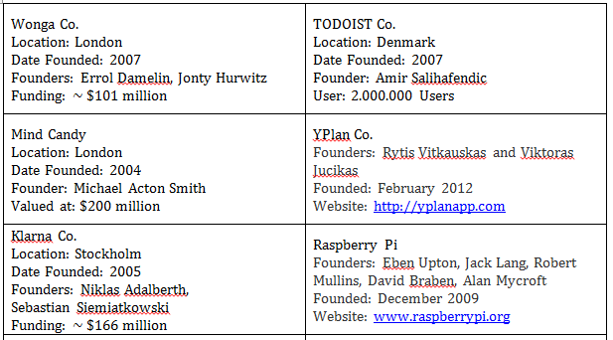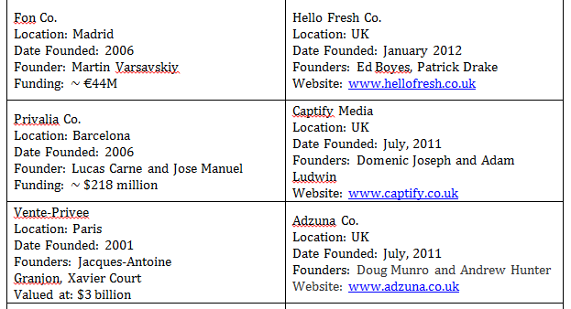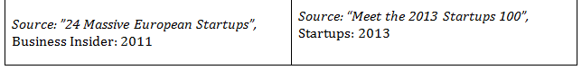

# References

Amit Chatterjee, (2010) *“Key Points to Building Success”* Available at: <http://ecorner.stanford.edu/author/amit_chatterjee>

Ash Muarya, (2010) *“Bootstrapping a Lean Startup”* Available at: <http://practicetrumpstheory.com/bootstrapping-a-lean-startup/>

Benjamin Yoskovitz, (2014) *“Corporate Suit vs Entrepreneur.”* Entrepreneurs Startups Magazine, pg. 14

Business Insider, (2011) *”24 Massive European Startups”* Available at: <http://www.businessinsider.com/most-valuable-startups-europe-2011-12?op=1>

CNN Money, (2014) *“Uber Valued at $18.2 Billion”* Available at: <http://money.cnn.com/2014/06/06/technology/innovation/uber-funding/>

Dean A. Shepherd, (2011) *“Nature of Entrepreneurial Opportunities.”* Entrepreneurial Opportunities: Colorado: Western Press, pg. 64-125

Erin Griffith, (2014) *“Why Startups fail, according to their founders”* Available at: <http://fortune.com/2014/10/15/ebay-outlook-signals-slow-holiday-season/>

Eric Ries, (2011) *“Entrepreneurial Management”* The Lean Startup: New York: Crown Publishing Group, pg. 17-43

Forbes, (2013) *“16 Surprising Statistics about Small Businesses”* Available at: <http://www.forbes.com/sites/jasonnazar/2013/09/09/16-surprising-statistics-about-small-businesses/>

George Deeb, (2013) *“The Unlucky 13 Reasons Startups Fail”* Available at: <http://www.forbes.com/sites/georgedeeb/2013/09/18/the-unlucky-13-reasons-startups-fail/>

Jolts, (2012) *“A Playlist for Entrepreneurs”* Available at: <http://ecorner.stanford.edu/author/daniel_ek>

Jessica Mah, (2011) *“Launching Too Early”* Available at: <http://ecorner.stanford.edu/author/jessica_mah>

Jolts, (2013) *“Essential Ingredients for a Startup”* Available at: <http://jolts.stanford.edu/76/key_success_factors_for_startups>

Joseph Pigato, (2013) *“Why I turned down Apply for Startup”* Available at: <http://www.fastcompany.com/3025459/leadership-now/why-i-turned-down-apple-for-a-startup>

Kevin Ready, (2011) *“Setting the Stage.”* Startup: Texas: Apress, pg. 3-24

Oncletom, (2012) *“Why Our Startup Failed”* Available at: <https://oncletom.io/2014/why-our-startup-failed>

Peter Cohan, (2012) *“What Big Companies Can Learn from Startups”* Available at: <http://www.forbes.com/sites/petercohan/2012/02/13/hbss-howard-stevenson-what-big-companies-can-learn-from-start-ups/>

Robert A. Barron, (2013) *“Tools for Making the Possible Real”* Enhancing Entrepreneurial Excellence: Oklahoma: University Press, pg. 122-148

The Lean Startup, (2013) *“The Lean Startup Methodology”* Available at: <http://theleanstartup.com/principles>

Twitpic, (2014) *“Twitpic is Shutting Down”* Available at: <http://blog.twitpic.com/2014/09/twitpic-is-shutting-down/>

US Bureau of International Information Programs, (2012) *“Principles of Entrepreneurship”* Available at: [www.ait.org.tw/infousa/zhtw/DOCS/enterp.pdf](http://www.ait.org.tw/infousa/zhtw/DOCS/enterp.pdf)

William Sahlman, (2007) *“The Three Critical Elements”* Stanford Technology Venture Program: Available at: <http://ecorner.stanford.edu/author/william_a_sahlman>